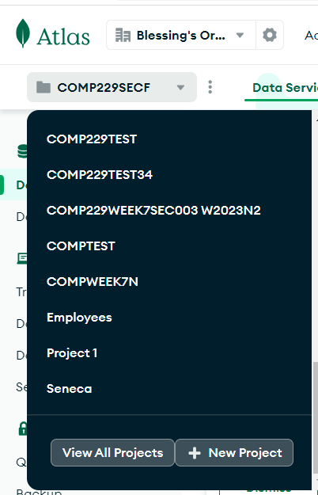

Click on New Project

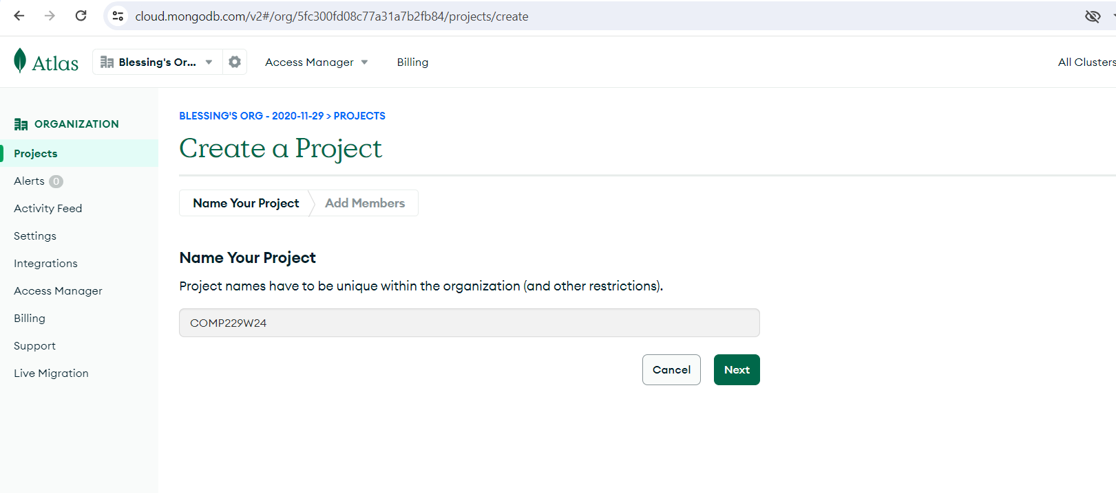

Click on Next

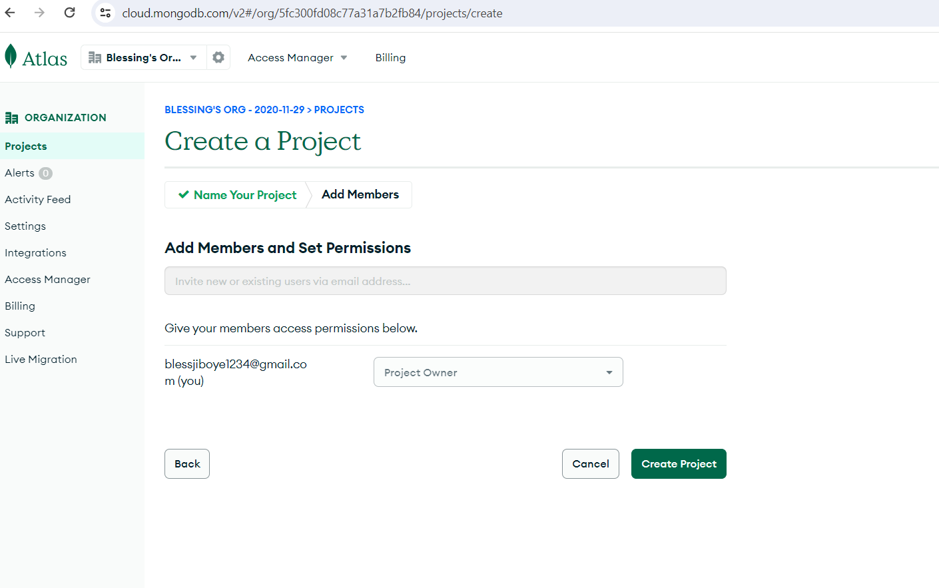

Click on Create Project

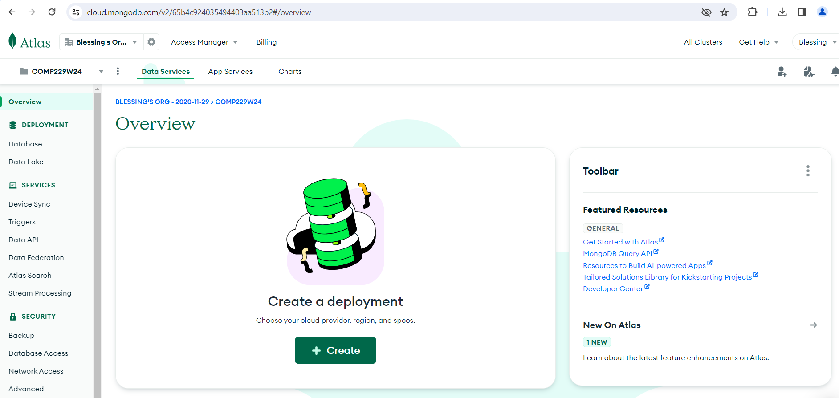

Click on +Create

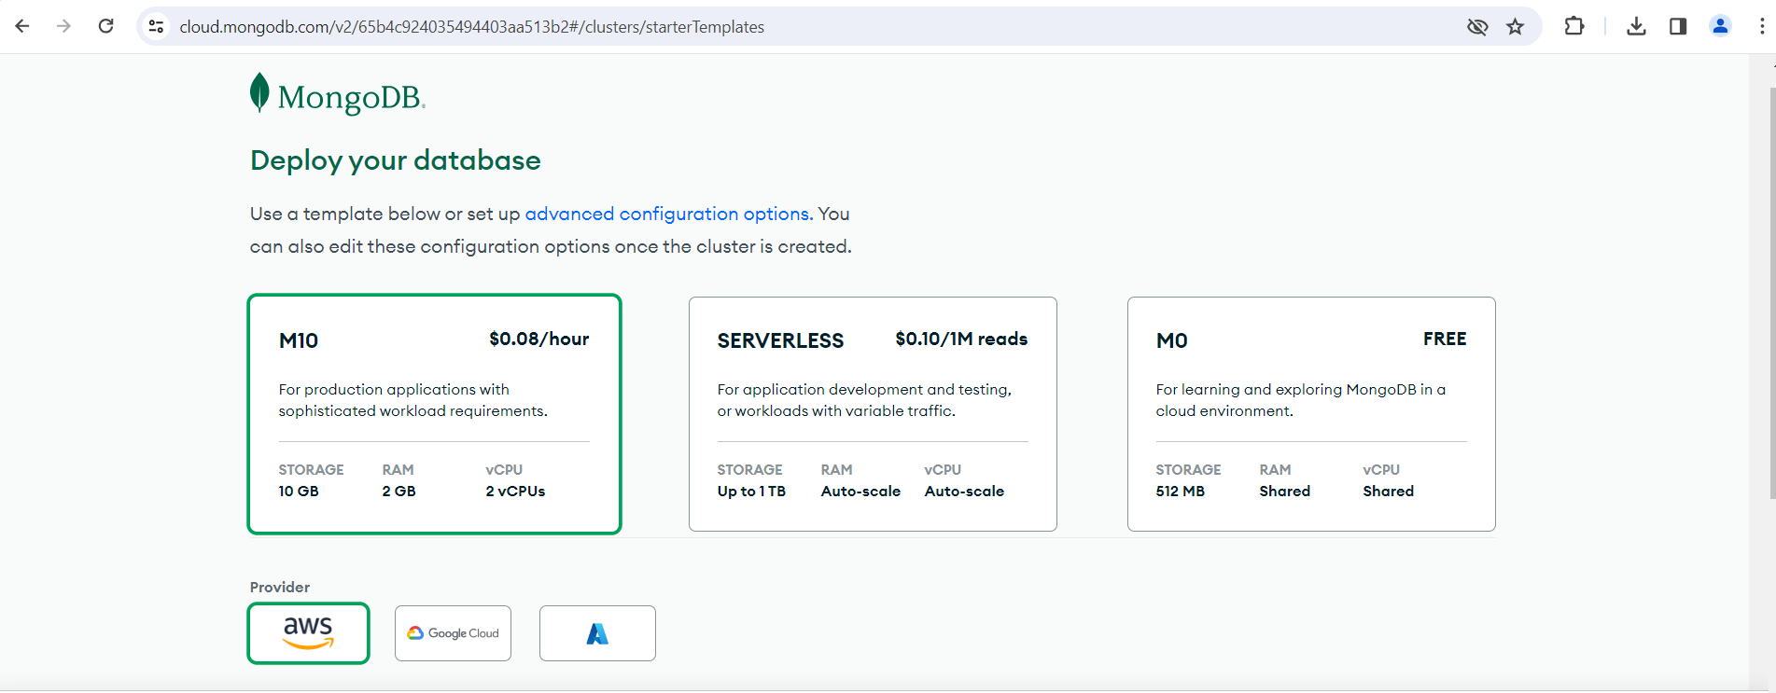

Select/Click on M0 Free click on A which stands for AZURE

Select Toronto (canadacentral) from the dropdown list

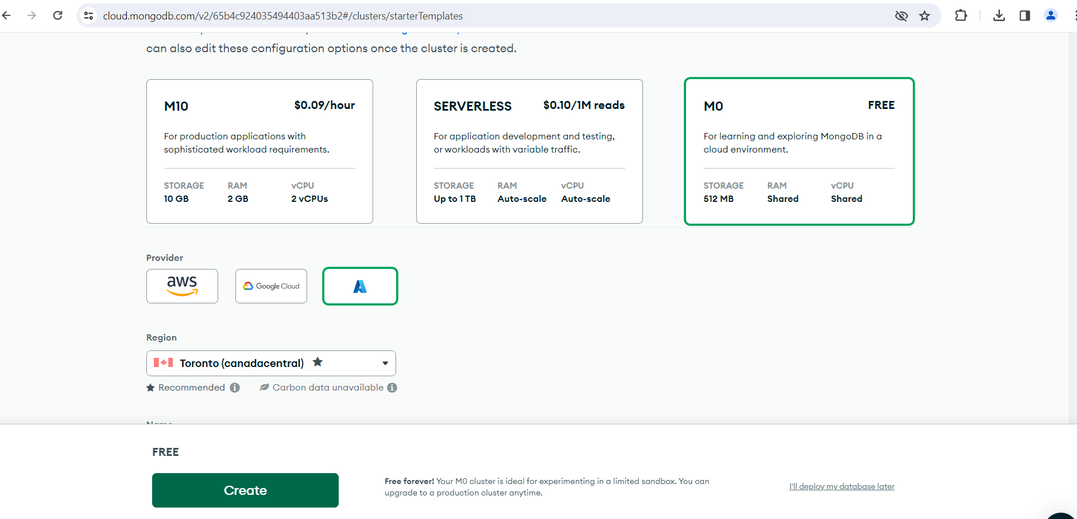

Click on create

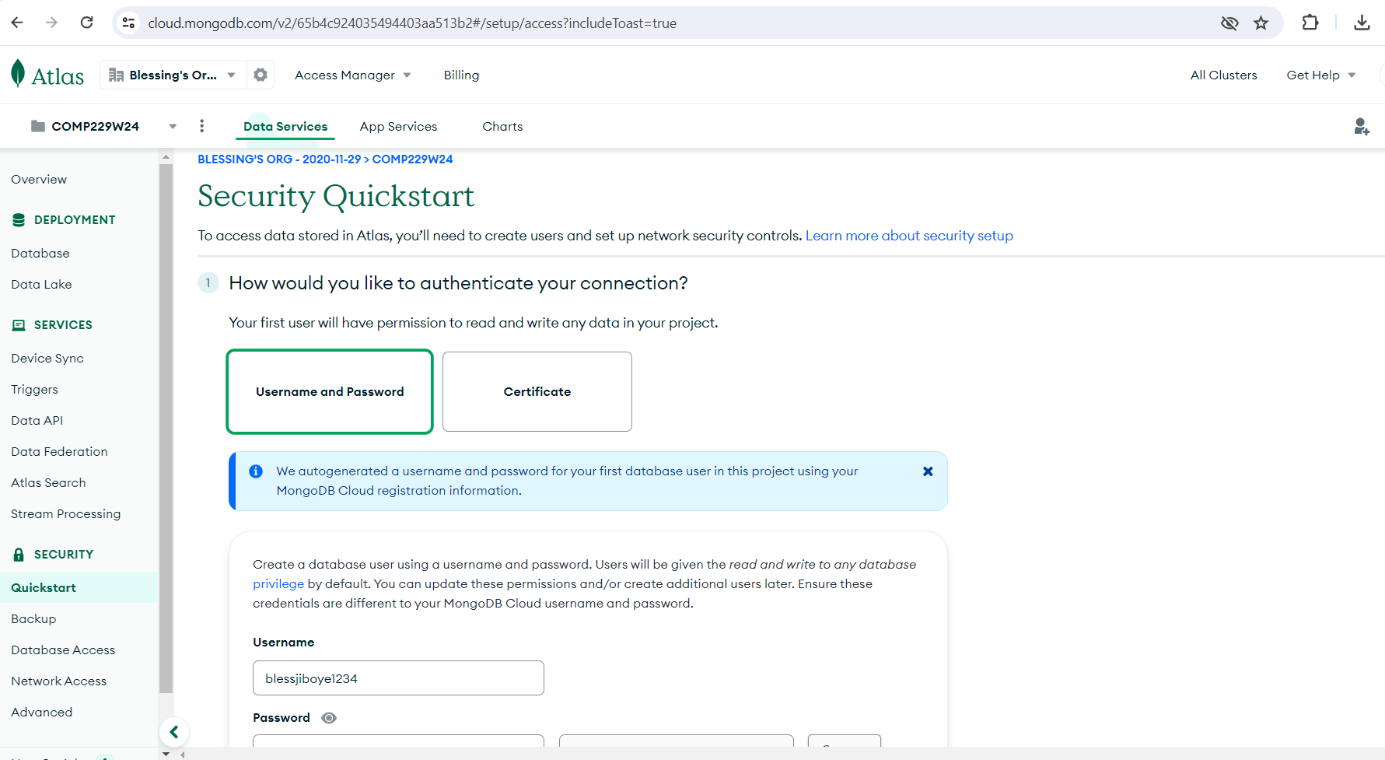

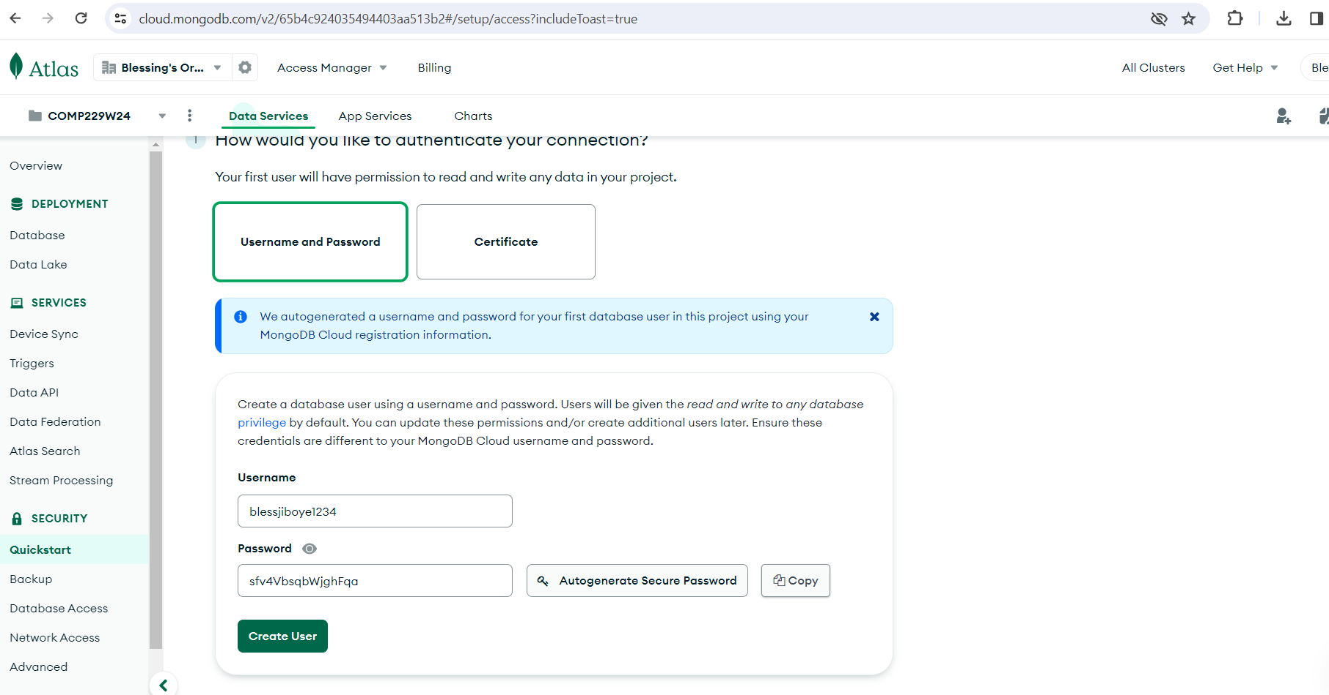

Set the username and password – you can autogenerate the password. Ensure to keep this credentials as you will need it to create your connection string.

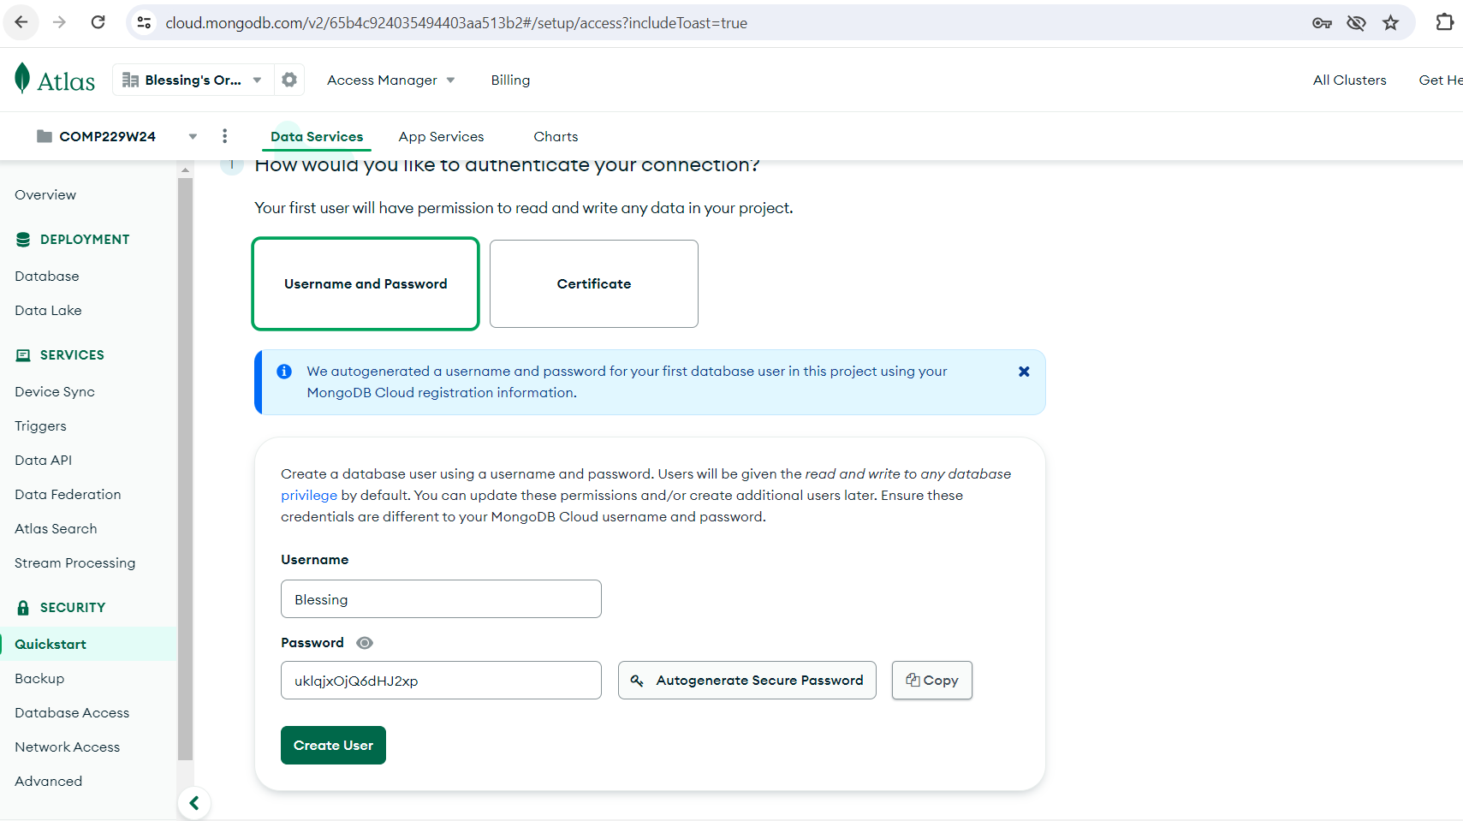

Username - Blessing

Password - uklqjxOjQ6dHJ2xp

Click on Create User

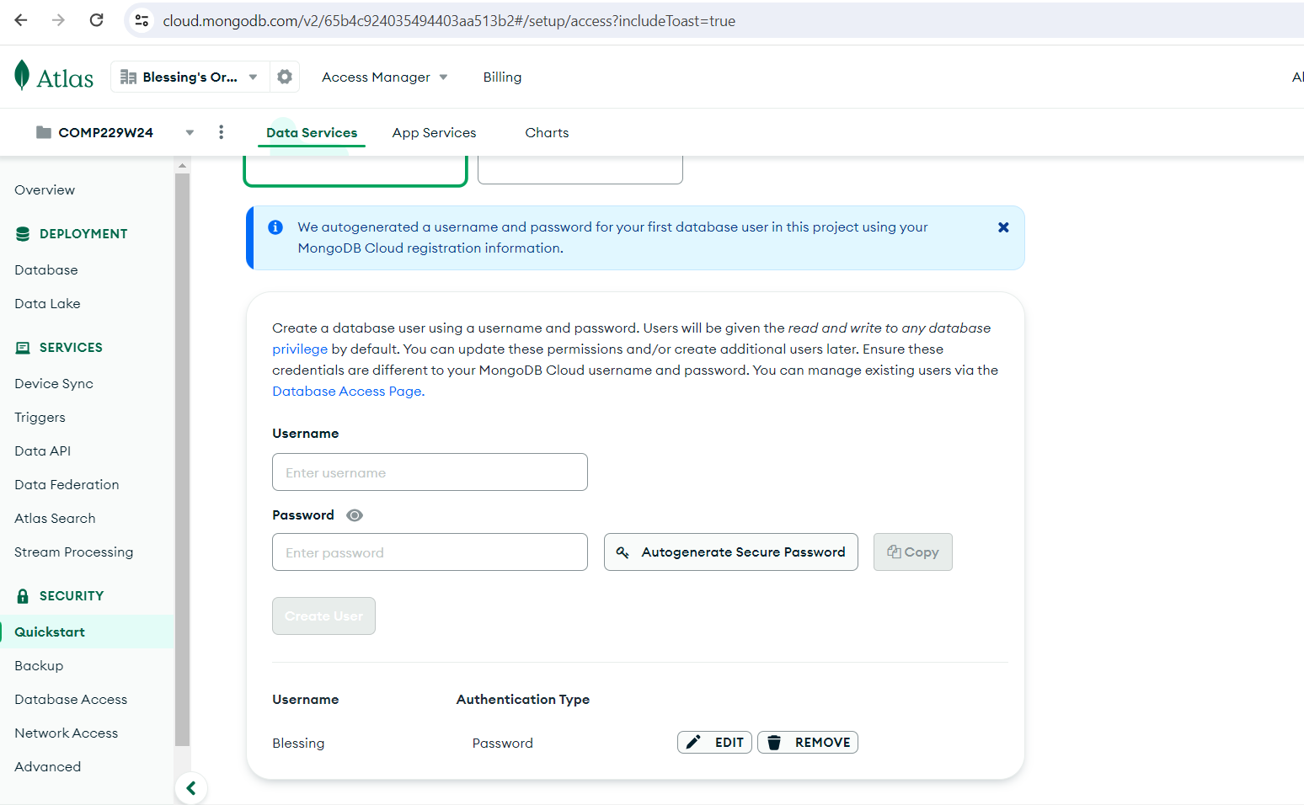

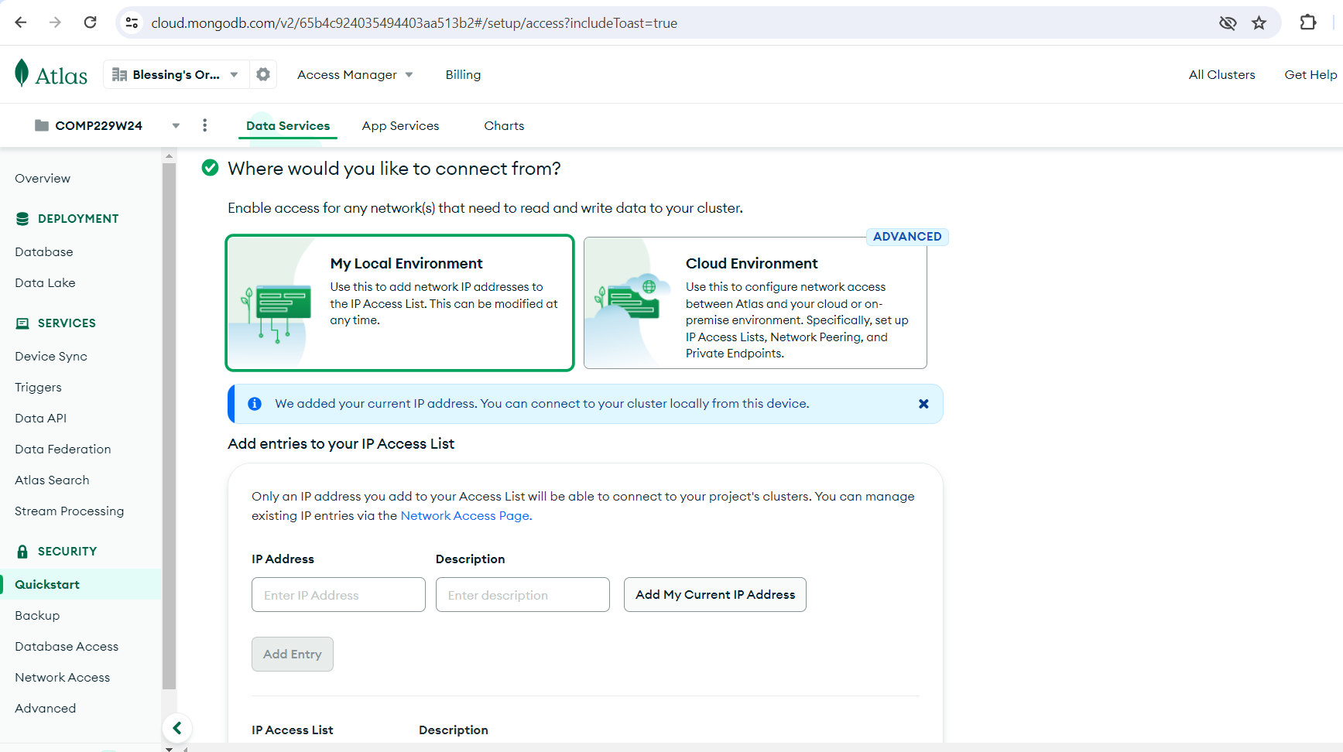

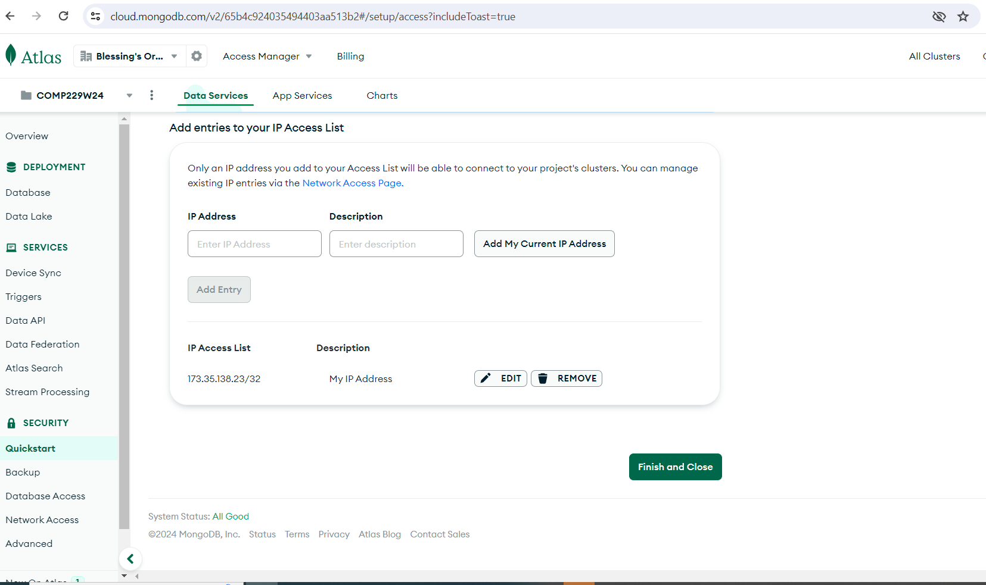

Click on finish and close

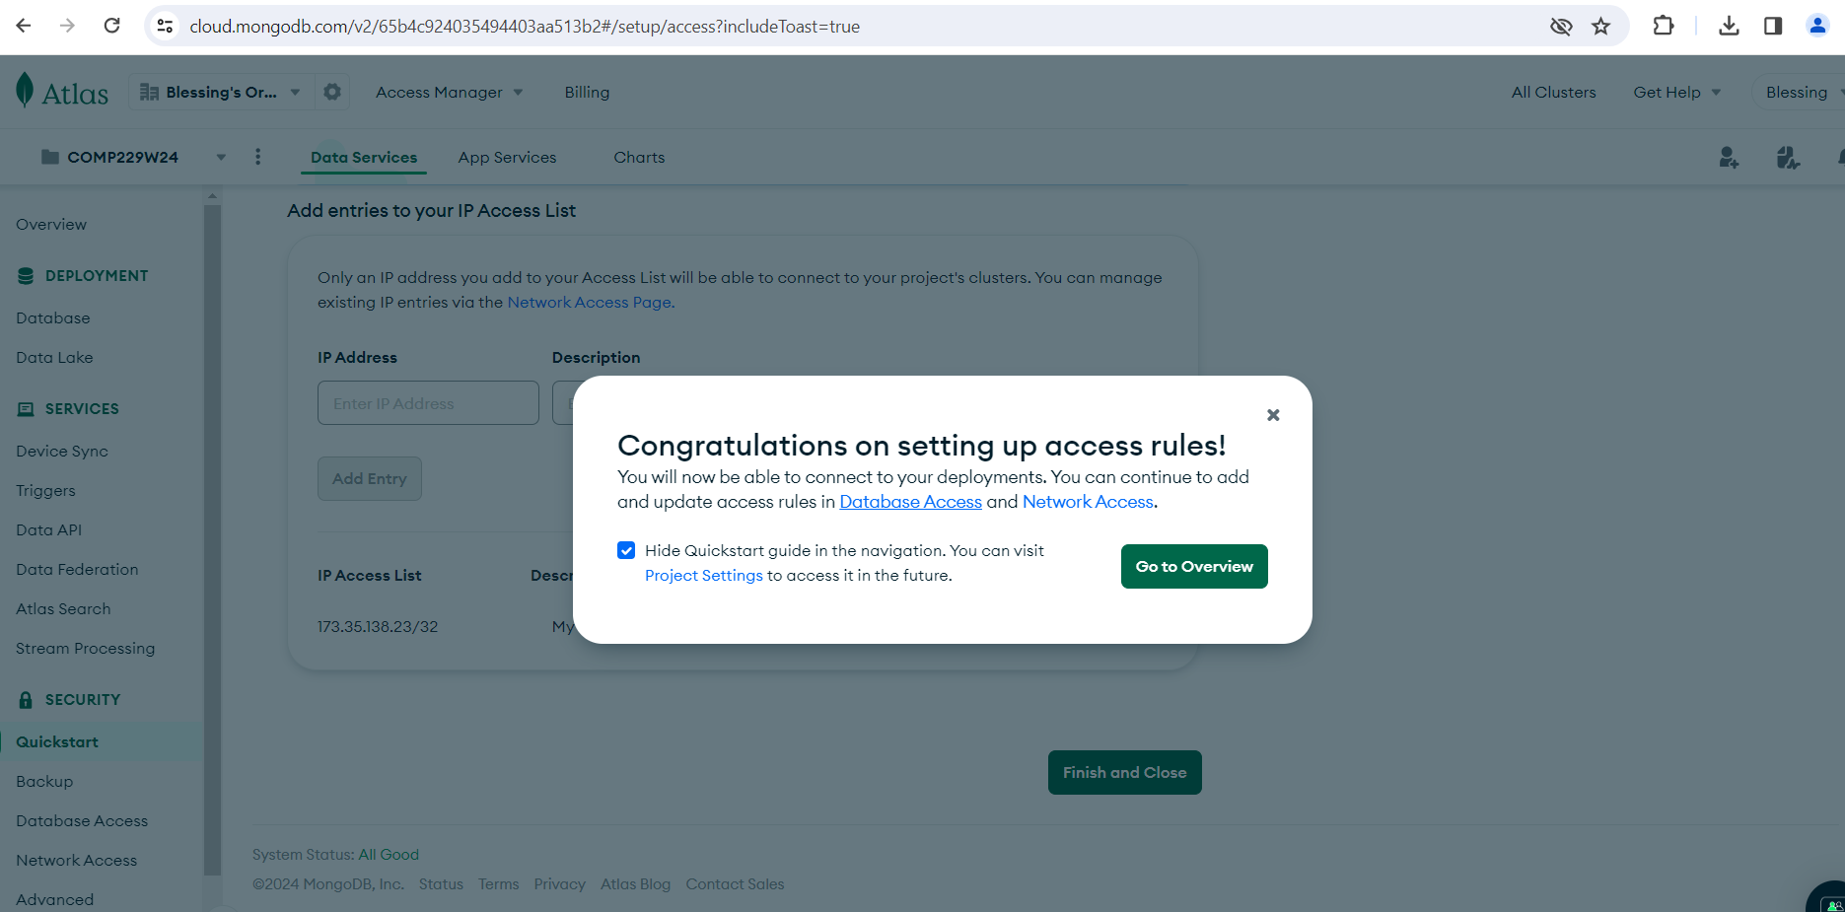

Close the dialog box.

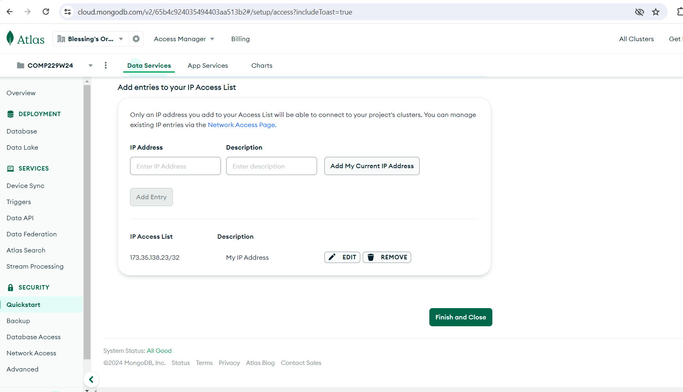

Click on Database on the lefthand side

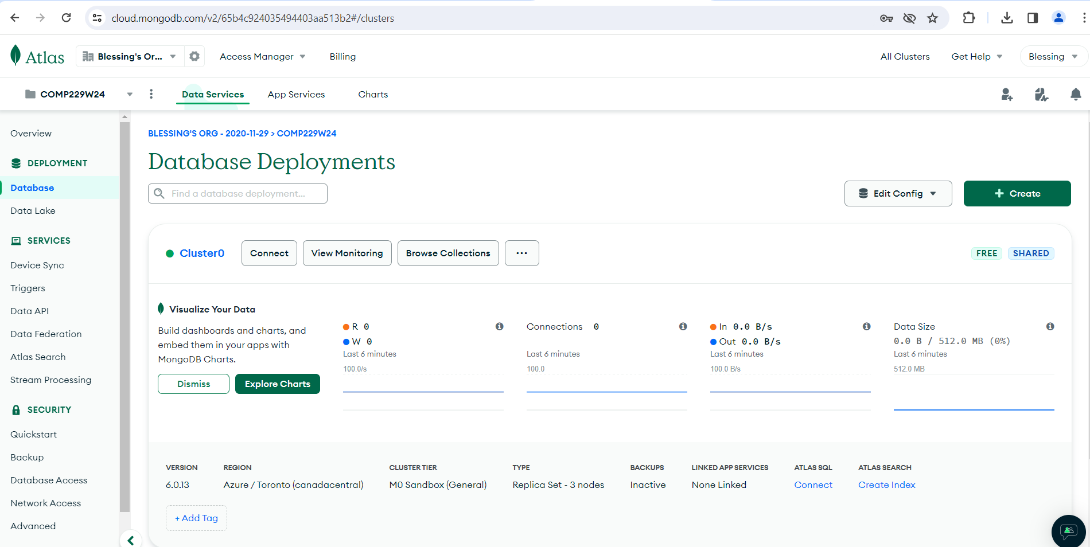

Click on Connect

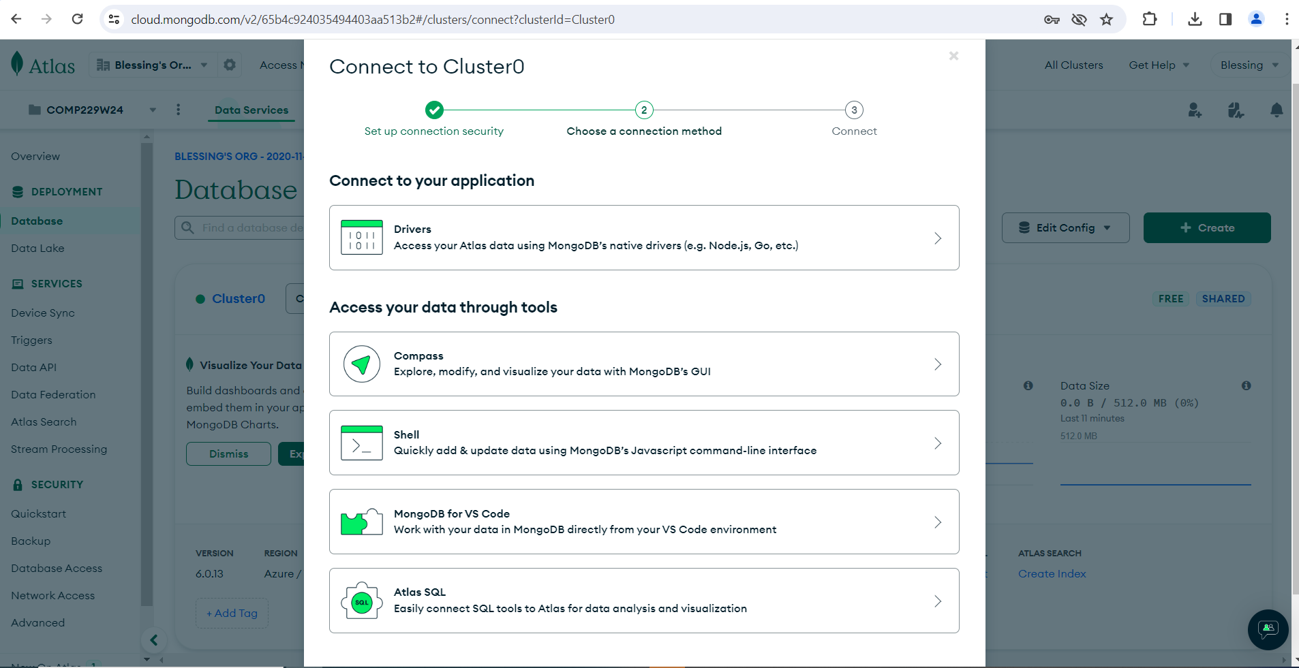

From connect to your application

Click on Drivers

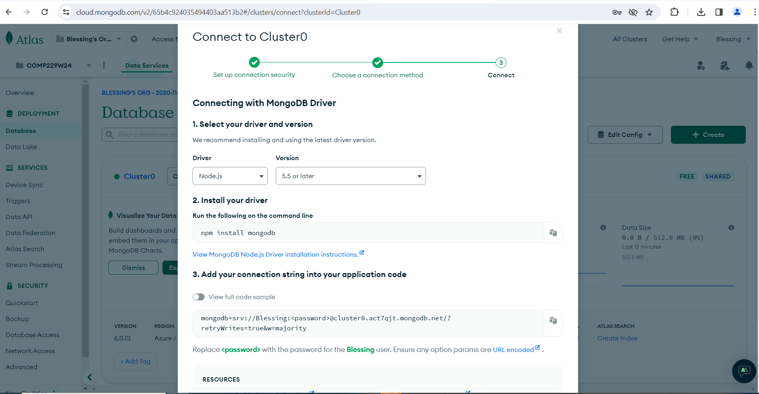

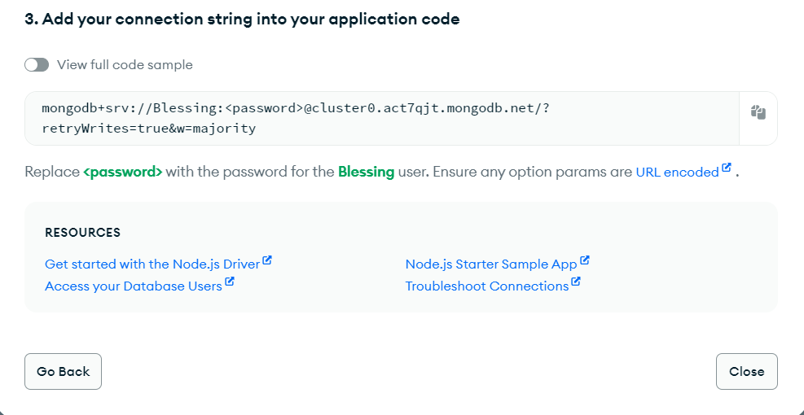

Copy the connection string from the number 3 Add connection string to your application code

mongodb+srv://Blessing:<password>@cluster0.act7qjt.mongodb.net/?retryWrites=true&w=majority

click on close

Replace the password with the one you created or autogenerated as follows in your connection string

mongodb+srv://Blessing: uklqjxOjQ6dHJ2xp @cluster0.act7qjt.mongodb.net/?retryWrites=true&w=majority

Now we need to create the Database name, collections and documents

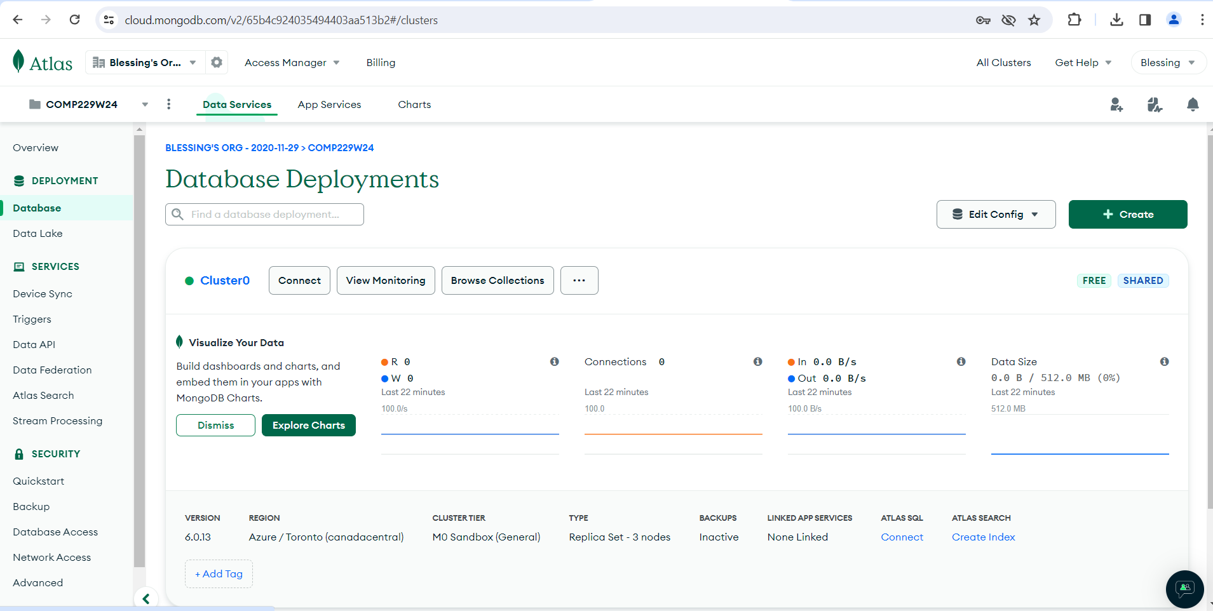

Click on Browse Collections

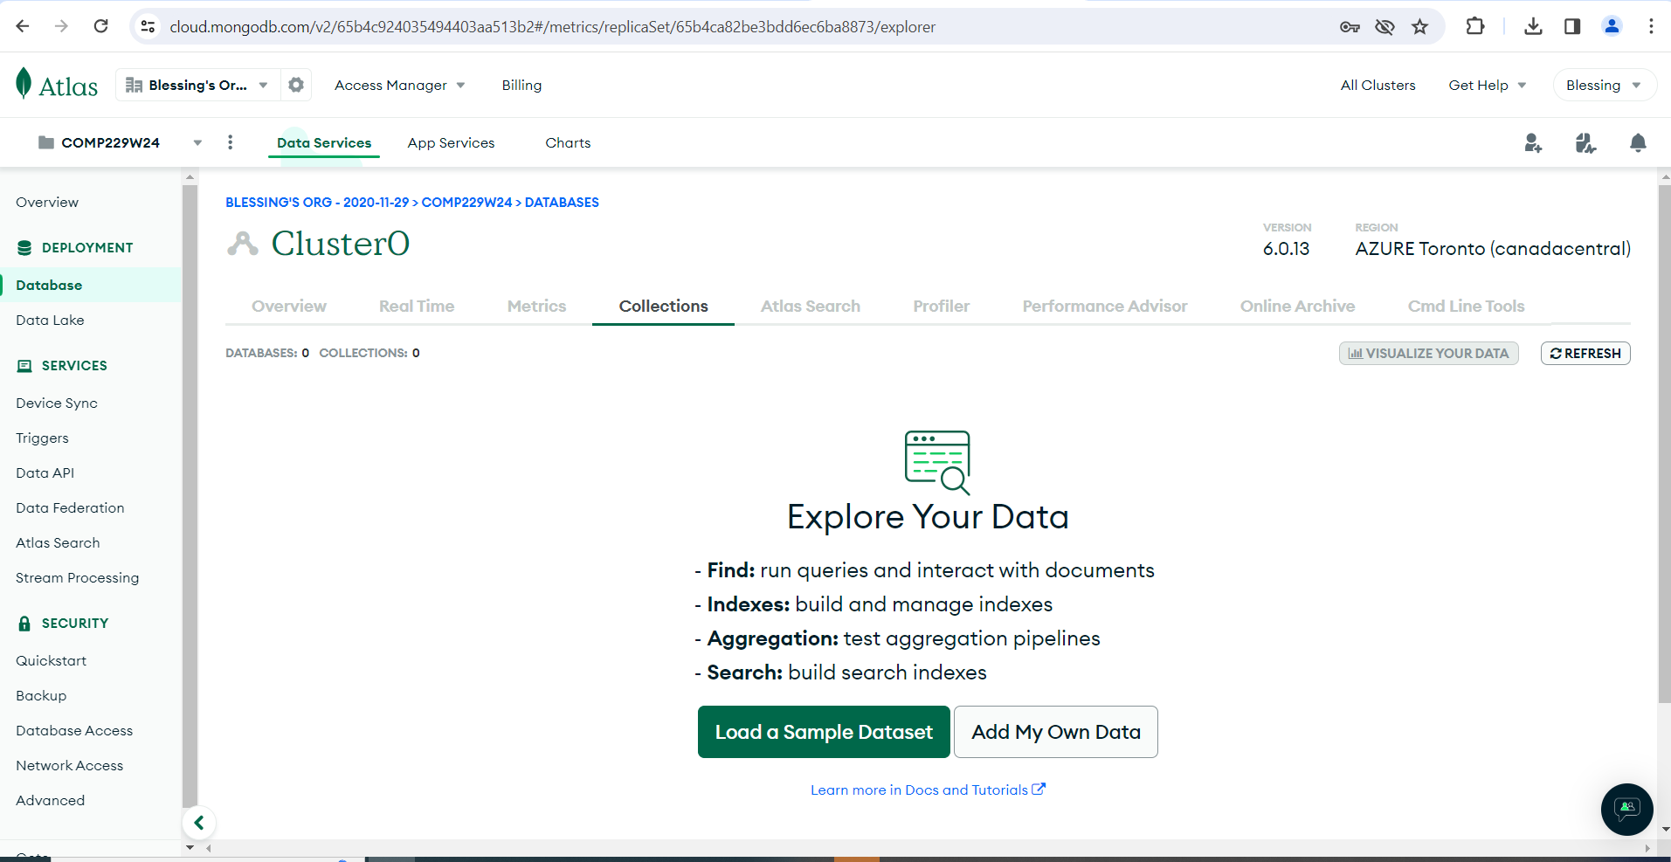

Click on Add My Own Data

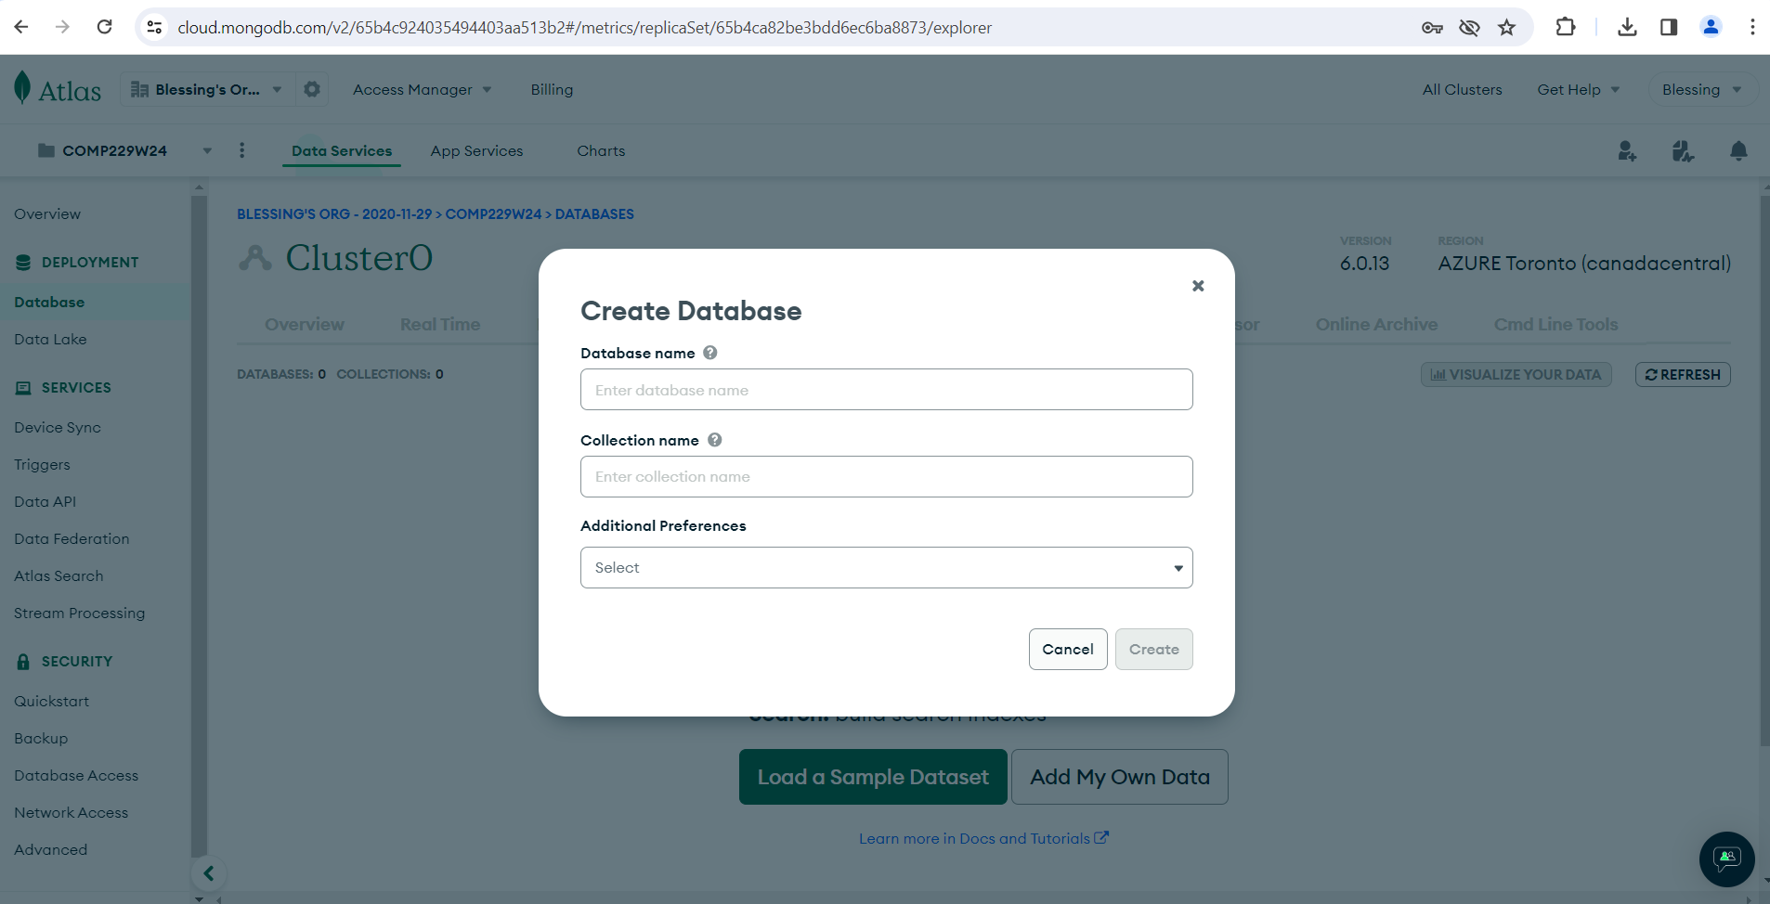

Enter the database name - Skeleton

Collection name - users

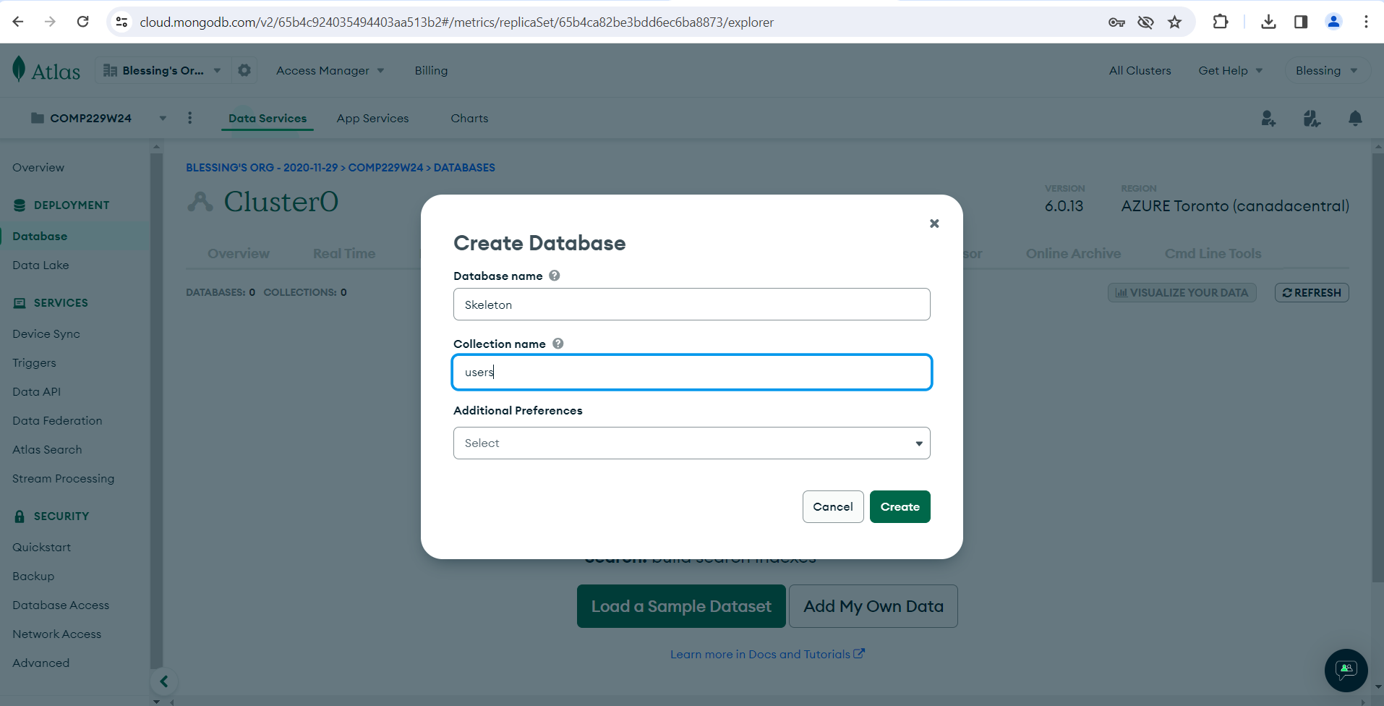

Click on create

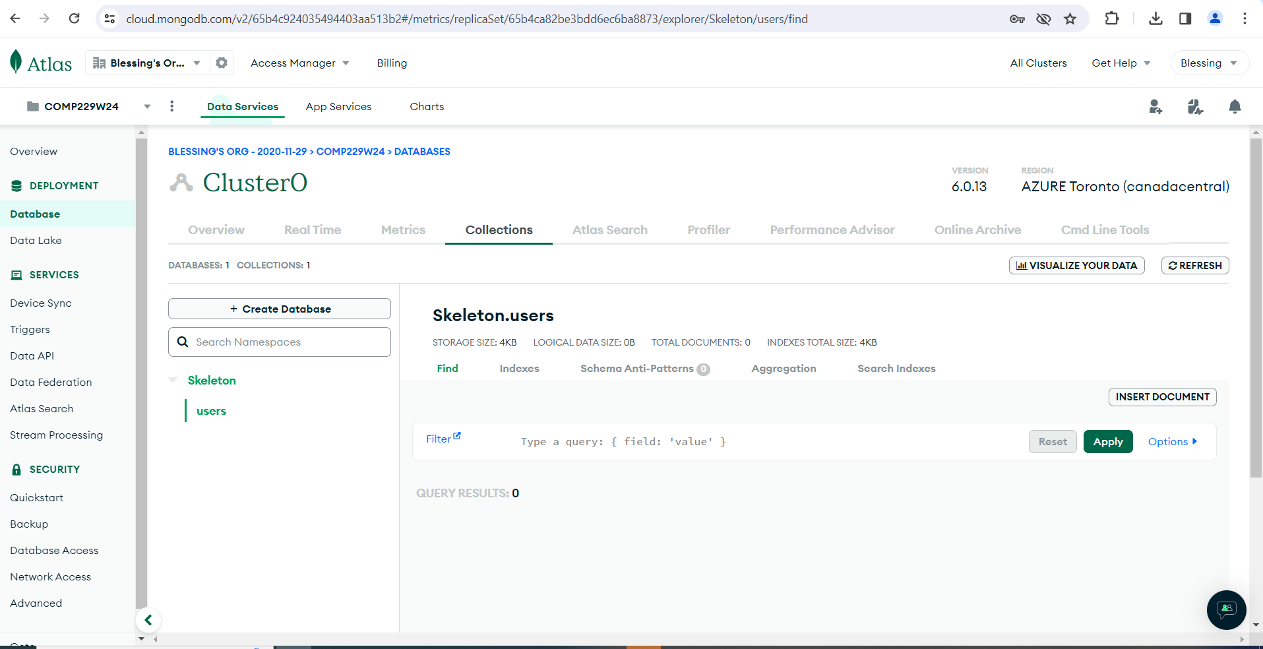

Click on INSERT DOCUMENT, to insert documents into the users collection

Using the following attributes

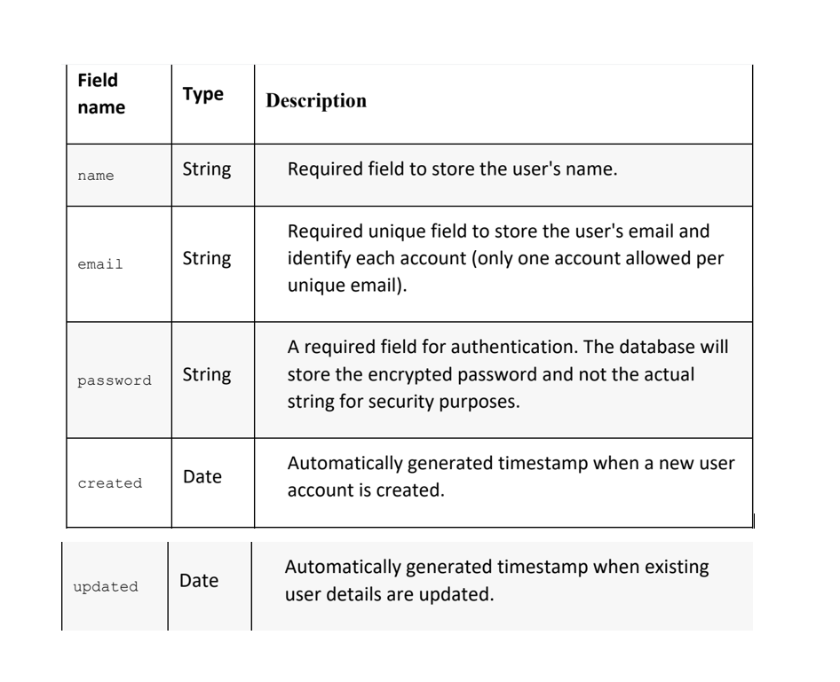

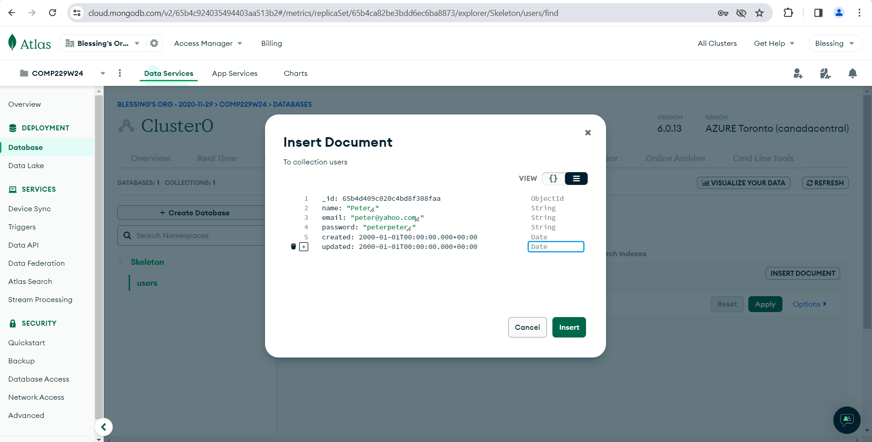

Click on Insert

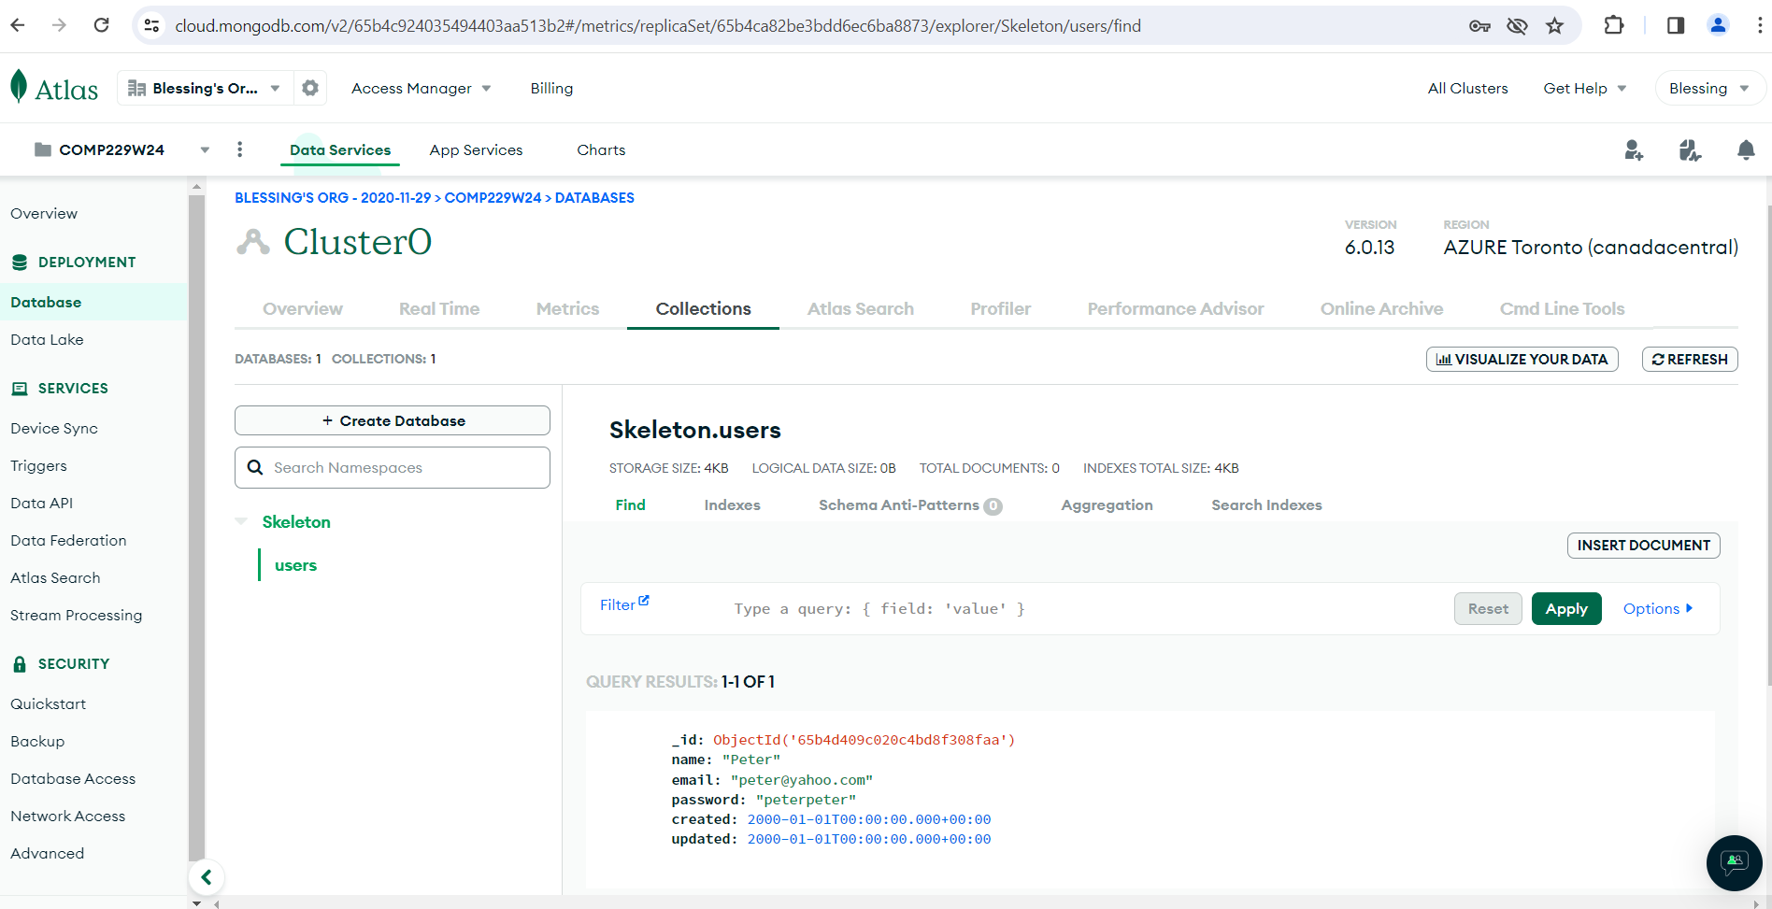

Add the database name to the connection string.

mongodb+srv://Blessing: uklqjxOjQ6dHJ2xp @cluster0.act7qjt.mongodb.net/Skeleton?retryWrites=true&w=majority

**OR**

From the cmd you can connect to your MongoDB Atlas using the connection string as follows but you must first run the server make sure it is running by opening a cmd and type mongod if successful the mongoDB server starts running then open another cmd to access the mongo shell, then type mongosh and the connection string as shown below::

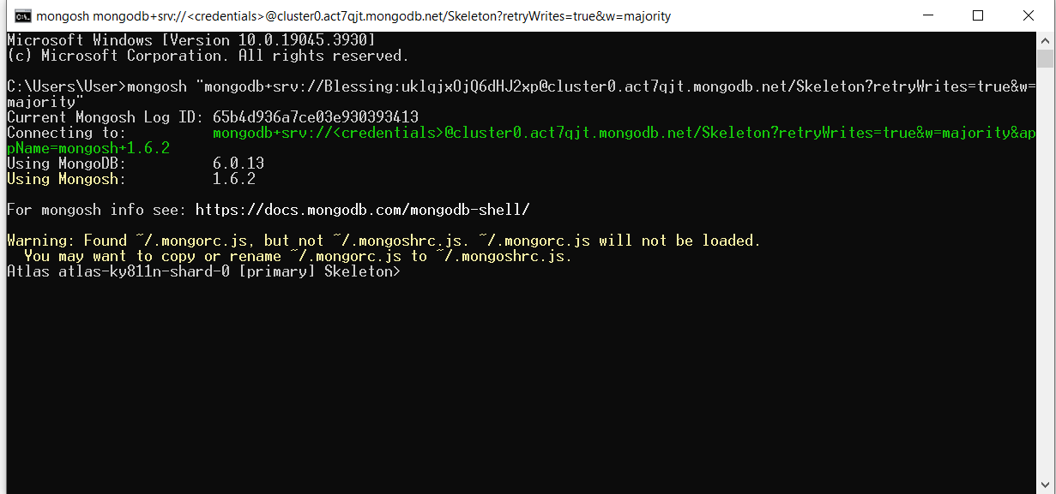

TEST

